NAME ____________________
GROUP __________
BENCH __________
IMPEDANCE OF A SERIES RCL CIRCUIT #1

OBJECTIVES:
The student will be able to indirectly measure impedance in a series RCL circuit, to use an oscilloscope to measure phase shift in a series RCL circuit, to calculate impedance and phase shift using the series impedance equation for a series RCL circuit, and be able to set up and record oscilloscope waveforms that show circuit conditions.
3V @ 20kHz
Function Generator
R1
100Ω
L1
4.7mH
Rw
C1
0.01uF

PROCEDURE:
1. Measure the Resistance (R_{W}) of the inductor, put your measurement in the blank provided on the
next page.

2. Connect the circuit shown above.

3. Measure E_{R p-p}, E_{L p-p}, E_{C p-p}, and I_{T p-p} (indirect).

4. Use Ohm’s Law to calculate total impedance (ZT). This will be recorded as an indirect
measurement.

5. Use the oscilloscope to measure circuit phase angle (Θ).

6. Calculate XL and XC at the frequency used.

7. Calculate Z_{T} and Θ using the Series Impedance Equation.

8. Calculate the % difference between the measured and calculated values of Z and Θ.

9. Record the time related waveforms for:

E (REFERENCE)

I (TOTAL)

E (CAPACITOR)

E (INDUCTOR)

RW (MEASURED) = ____________ L (MEASURED) = ____________

SCOPE MEASUREMENTS
Step 3 |  |  |  |  |  |  |  | Step 4 | Step 7 | Step 8
ER |  | (I) MEAS  INDIRECT |  | EL |  | EC |  | (Z) MEAS  INDIRECT | ZCALC | % DIFF
P-P | RMS | P-P | RMS | P-P | RMS | P-P | RMS | (Z) MEAS  INDIRECT | ZCALC | % DIFF

Step 6 |  | Step 5 | Step 7 | Step 8
XL | XC | Θ MEAS  SCOPE | Θ CALC | DIFF Θ

IS THE TOTAL IMPEDANCE CAPACITIVE OR INDUCTIVE? ____________________

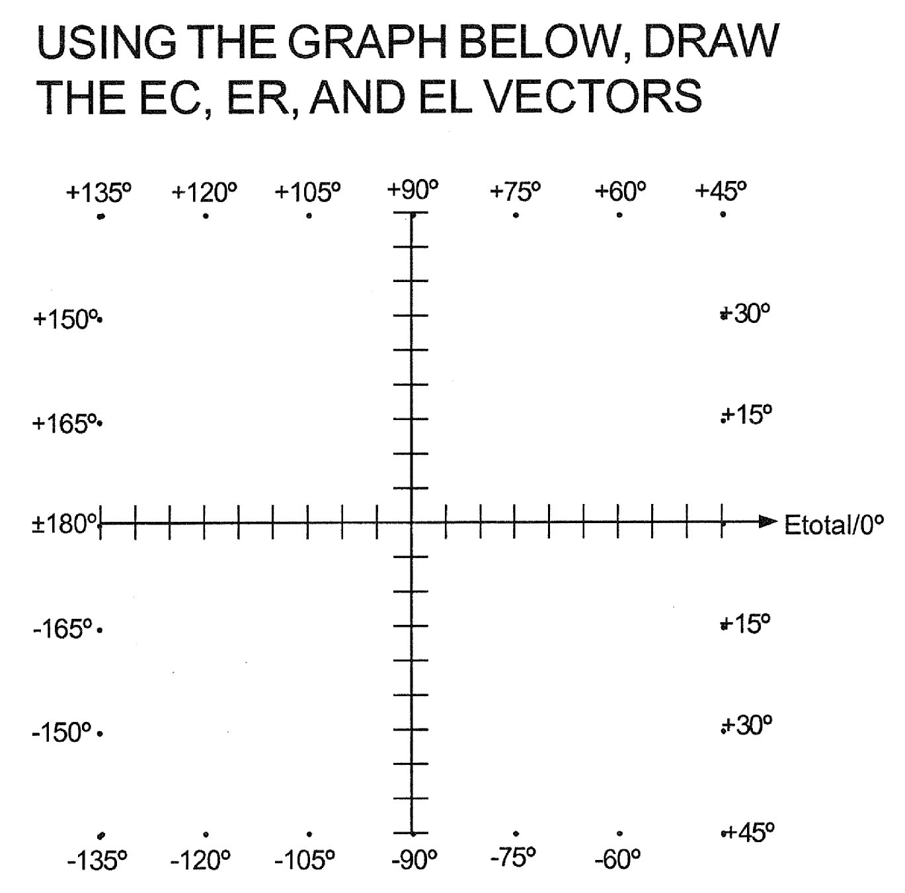
DRAW THE IMPEDANCE TRIANGLE
IN THE SPACE BELOW.

